Run Microservice

Contents

Steps to Add Microservices in eclipse: 1

Sequence of running microservices: 3

Steps to run eb-configserver-microservice: 3

Steps to run mds-registration-microservice: 4

# 

# Steps to Add Microservices in eclipse:

1.Open VSTS

2.Click on **clone** and copy the url

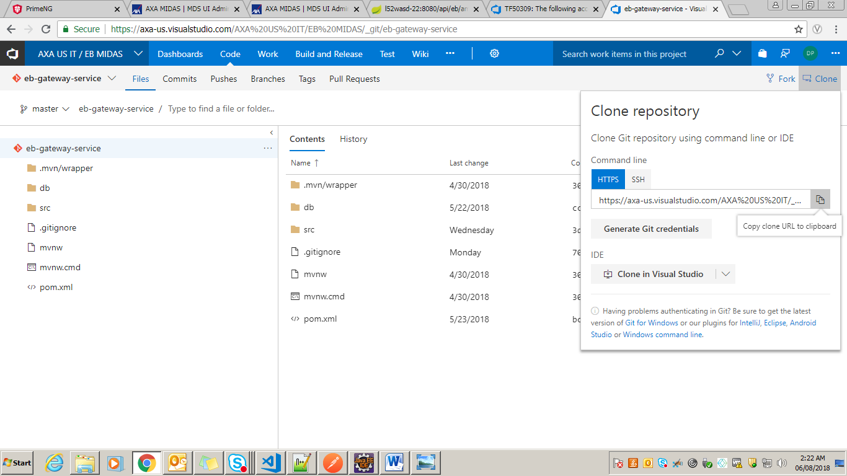

3.Open eclipse -> window -> Show view -> other -> git -> git repositories

4. Click on **ok**

5. open **Git Reopsitories**

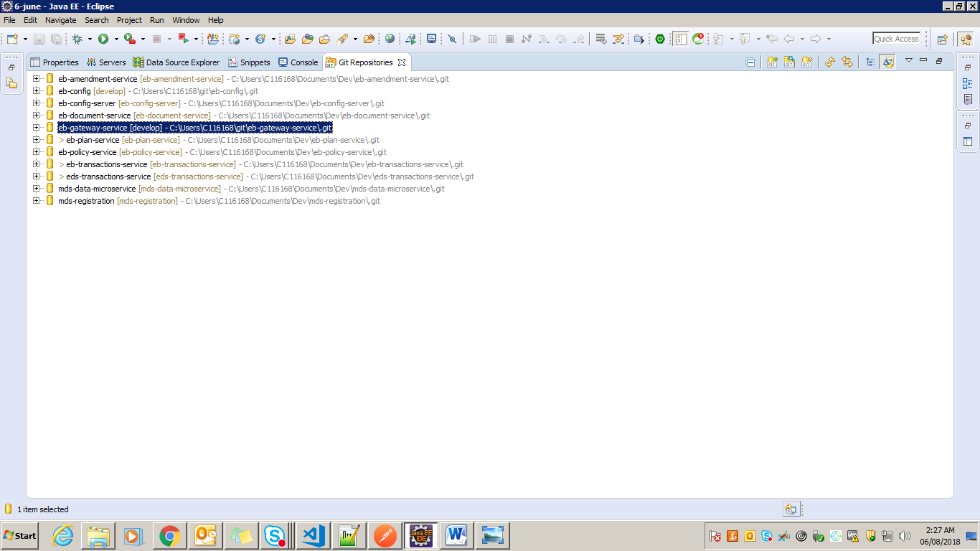

6. right click on empty space and add file to git repositories

7. right click on project and click on import project

8. follow 1-7 steps for all microservices

# Sequence of running microservices:

1.eb-configserver-microservice

2.mds-registration-miceroservice

3.eb-gateway-service

4.mds-data-microservice

5.after that any microservice

With the new security changes, there are certain steps developers need to start services locally.

Once started all API paths are routed through the gateway running on port 8080.

Example API URL: <http://localhost:8080/api/t1/ebGenderses>

1. Clone **eb-configserver-microservice** and **eb-gateway-service** if you haven’t already
2. If you are working on a feature branch, ensure the latest Dev code has been back merged
3. Start **eb-configserver-microservice**
   1. In run configurations set **Profile = local**
   2. In override properties set **local.repo** = {absolute path to your root git folder}

                                                    i.     Example: local.repo = C:\Users\C115089\EB-API

1. Start **mds-registration-service**
   1. Profile = dev (shouldn’t matter really)
   2. In override properties set spring.cloud.config.label = develop
2. Start **eb-gateway-service**
   1. Profile = local,dev
   2. spring.cloud.config.label = develop
3. Start any Tier 1 services you require
   1. Profile = local,dev
   2. spring.cloud.config.label = develop
   3. encryptionKey = eb_key
4. Start any Tier 2 or Tier 3 services
   1. Profile = local,dev
   2. spring.cloud.config.label = develop
5. For **eb-documents-service** and **eb-transactions-service**, you also may require:
   1. jasypt.encryptor.password = eb_key
   2. jcifs.resolveOrder = DNS
   3. jcifs.smb.client.dfs.disabled = true

# Steps to run eb-configserver-microservice:

1.go to **Run Configuration -> spring boot App->New**

**2. select main type , Project**

**3.** set profile as **local**

4.add property as **local.repo**

5. right click on **eb-config** project in project explorer

6. go to **properties** copy **location** value

7.Paste as value of **local.repo** property replace all backward slashes with forward slashes

8. click **Apply** and then **Run**

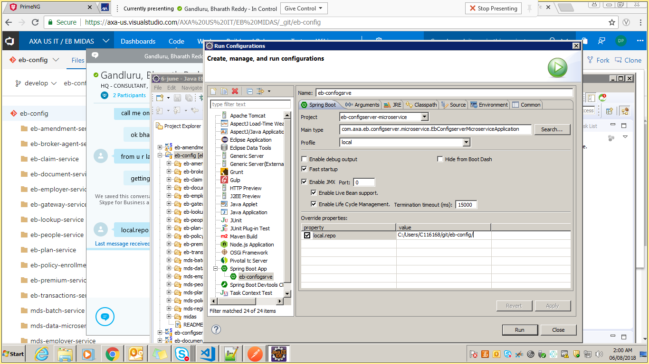

# Steps to run mds-registration-microservice:

1. **Run configuration**
2. Select Main Type and Project
3. Set profile as **dev**
4. Add property **spring.cloud.config.label** and value as **develop**
5. Add property **spring.config.location** and value(right click on project-> properties->copy location->paste in value field->replace all backward slashes with forward slashes)

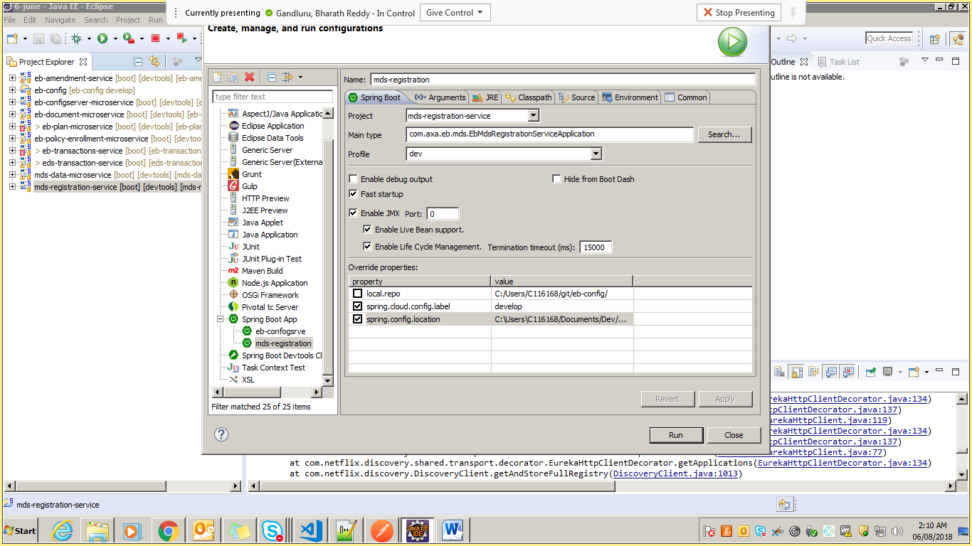

**Follow same steps to run eb-gateway-service ,mds-data-microservice and other services(set profile as local,dev)**

